# **BGP Policy Practice 2017**

* This topology is meant to provide many prefixes with a variety of mask lengths sourced from several autonomous systems.
* BGP policies will be written and implemented in AS1.
* The effect of the policies will be observed in AS2.

## **Topology**

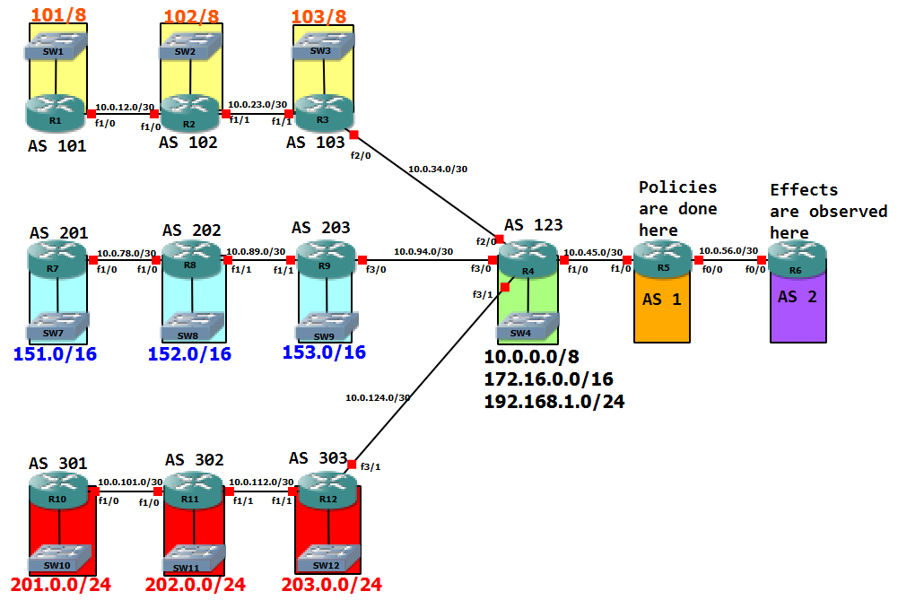

VLANs

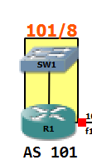

config terminal

interface f0/0

no shut

interface f0/0.10

encapsulation dot1q

ip address 101.0.0.1 255.240.0.0

description "prefix with mask /12"

interface f0/0.11

encapsulation dot1q

ip address 101.16.0.1 255.240.0.0

description "prefix with mask /12"

interface f0/0.12

encapsulation dot1q

ip address 101.32.0.1 255.224.0.0

description "prefix with mask /11"

interface f0/0.13

encapsulation dot1q

ip address 101.64.0.1 255.192.0.0

description "prefix with mask /10"

interface f0/0.14

encapsulation dot1q

ip address 101.128.0.1 255.128.0.0

description "prefix with mask /9"

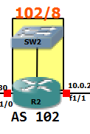

config terminal

interface f0/0

no shut

interface f0/0.10

encapsulation dot1q

ip address 102.0.0.1 255.248.0.0

description "prefix with mask /13"

interface f0/0.11

encapsulation dot1q

ip address 102.16.0.1 255.248.0.0

description "prefix with mask /13"

interface f0/0.12

encapsulation dot1q

ip address 102.32.0.1 255.240.0.0

description "prefix with mask /12"

interface f0/0.13

encapsulation dot1q

ip address 102.64.0.1 255.224.0.0

description "prefix with mask /11"

interface f0/0.14

encapsulation dot1q

ip address 102.128.0.1 255.192.0.0

description "prefix with mask /10"

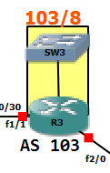

config terminal

interface f0/0

no shut

interface f0/0.10

encapsulation dot1q

ip address 103.0.0.1 255.252.0.0

description "prefix with mask /14"

interface f0/0.11

encapsulation dot1q

ip address 103.16.0.1 255.252.0.0

description "prefix with mask /14"

interface f0/0.12

encapsulation dot1q

ip address 103.32.0.1 255.248.0.0

description "prefix with mask /13"

interface f0/0.13

encapsulation dot1q

ip address 103.64.0.1 255.240.0.0

description "prefix with mask /12"

interface f0/0.14

encapsulation dot1q

ip address 103.128.0.1 255.224.0.0

description "prefix with mask /11"

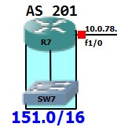

config terminal

interface f0/0

no shut

interface f0/0.10

encapsulation dot1q

ip address 151.0.0.1 255.255.240.0

description "prefix with mask /20"

interface f0/0.11

encapsulation dot1q

ip address 151.16.0.1 255.255.240.0

description "prefix with mask /20"

interface f0/0.12

encapsulation dot1q

ip address 151.32.0.1 255.255.224.0

description "prefix with mask /19"

interface f0/0.13

encapsulation dot1q

ip address 151.64.0.1 255.255.192.0

description "prefix with mask /18"

interface f0/0.14

encapsulation dot1q

ip address 151.128.0.1 255.255.128.0

description "prefix with mask /17"

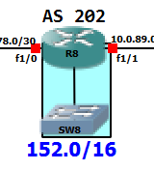

config terminal

interface f0/0

no shutdown

interface f0/0.10

encapsulation dot1q

ip address 152.0.0.1 255.255.240.0

description "prefix with mask /20"

interface f0/0.11

encapsulation dot1q

ip address 152.16.0.1 255.255.240.0

description "prefix with mask /20"

interface f0/0.12

encapsulation dot1q

ip address 152.32.0.1 255.255.224.0

description "prefix with mask /19"

interface f0/0.13

encapsulation dot1q

ip address 152.64.0.1 255.255.192.0

description "prefix with mask /18"

interface f0/0.14

encapsulation dot1q

ip address 152.128.0.1 255.255.128.0

description "prefix with mask /17"

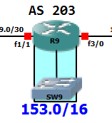

config terminal

interface f0/0

no shut

interface f0/0.10

encapsulation dot1q

ip address 153.0.0.1 255.255.240.0

description "prefix with mask /20"

interface f0/0.11

encapsulation dot1q

ip address 153.16.0.1 255.255.240.0

description "prefix with mask /20"

interface f0/0.12

encapsulation dot1q

ip address 153.32.0.1 255.255.224.0

description "prefix with mask /19"

interface f0/0.13

encapsulation dot1q

ip address 153.64.0.1 255.255.192.0

description "prefix with mask /18"

interface f0/0.14

encapsulation dot1q

ip address 153.128.0.1 255.255.128.0

description "prefix with mask /17"

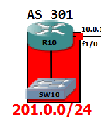

config terminal

interface f0/0

no shut

interface f0/0.10

encapsulation dot1q

ip address 201.0.0.1 255.255.255.240

description "prefix with mask /28"

interface f0/0.11

encapsulation dot1q

ip address 201.16.0.1 255.255.255.240

description "prefix with mask /28"

interface f0/0.12

encapsulation dot1q

ip address 201.32.0.1 255.255.255.224

description "prefix with mask /27"

interface f0/0.13

encapsulation dot1q

ip address 201.64.0.1 255.255.255.192

description "prefix with mask /26"

interface f0/0.14

encapsulation dot1q

ip address 201.128.0.1 255.255.255.128

description "prefix with mask /25"

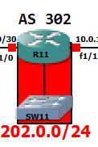

config terminal

Interface f0/0

no shutdown

interface f0/0.10

encapsulation dot1q

ip address 202.0.0.1 255.255.255.240

description "prefix with mask /28"

interface f0/0.11

encapsulation dot1q

ip address 202.16.0.1 255.255.255.240

description "prefix with mask /28"

interface f0/0.12

encapsulation dot1q

ip address 202.32.0.1 255.255.255.224

description "prefix with mask /27"

interface f0/0.13

encapsulation dot1q

ip address 202.64.0.1 255.255.255.192

description "prefix with mask /26"

interface f0/0.14

encapsulation dot1q

ip address 202.128.0.1 255.255.255.128

description "prefix with mask /25"

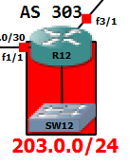

config terminal

interface f0/0

no shut

interface f0/0.10

encapsulation dot1q

ip address 203.0.0.1 255.255.255.240

description "prefix with mask /28"

interface f0/0.11

encapsulation dot1q

ip address 203.16.0.1 255.255.255.240

description "prefix with mask /28"

interface f0/0.12

encapsulation dot1q

ip address 203.32.0.1 255.255.255.224

description "prefix with mask /27"

interface f0/0.13

encapsulation dot1q

ip address 203.64.0.1 255.255.255.192

description "prefix with mask /26"

interface f0/0.14

encapsulation dot1q

ip address 203.128.0.1 255.255.255.128

description "prefix with mask /25"